**Dzükou Valley - Heaven on Earth**

The **Dzüko Valley** is a valley located at the borders of the states of [Nagaland](https://en.wikipedia.org/wiki/Nagaland) and [Manipur](https://en.wikipedia.org/wiki/Manipur) in [Northeast India](https://en.wikipedia.org/wiki/Northeast_India). This valley is well known for its natural environment, seasonal flowers and flora & fauna.

It is situated at an altitude of 2452 m above sea level. The valley is famous for its wide range of flowers in every season but the most famous one is the Dzüko Lily and it is found only in this valley.

he main entry is from the foothills of [Viswema](https://en.wikipedia.org/wiki/Viswema" \o "Viswema) where one can travel to the rest house above [Teyozwü Hill](https://en.wikipedia.org/wiki/Teyozw%C3%BC_Hill" \o "Teyozwü Hill) by a [Tata Sumo](https://en.wikipedia.org/wiki/Tata_Sumo) taxi. From here one has to climb forty minutes to the top of the mountain *(Khiyoke)*

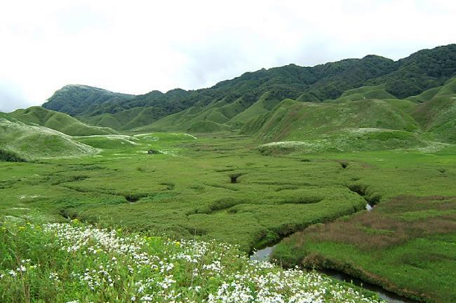

2nd photo:

<https://www.google.com/search?q=Dz%C3%BCkou+Valley+-+Heaven+on+Earth&rlz=1C1CHBD_enIN932IN932&sxsrf=AOaemvLm0TE3vW7qi--Q4HM0V6kfwrRTCg:1633014061218&source=lnms&tbm=isch&sa=X&ved=2ahUKEwj0uKC4-6bzAhWTxjgGHSDXDV0Q_AUoAXoECAEQAw&biw=1536&bih=754&dpr=1.25#imgrc=19c62V1vBm63DM>

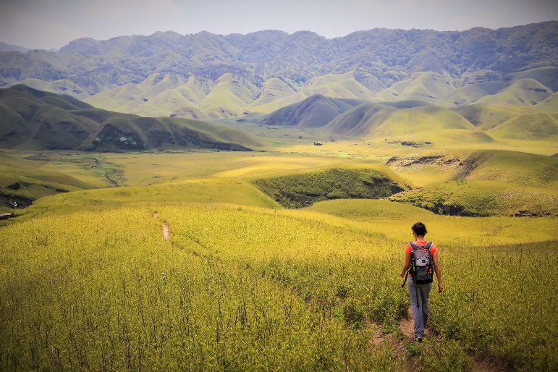

1st photo:

<https://www.google.com/search?q=Dz%C3%BCkou+Valley+-+Heaven+on+Earth&rlz=1C1CHBD_enIN932IN932&sxsrf=AOaemvLm0TE3vW7qi--Q4HM0V6kfwrRTCg:1633014061218&source=lnms&tbm=isch&sa=X&ved=2ahUKEwj0uKC4-6bzAhWTxjgGHSDXDV0Q_AUoAXoECAEQAw&biw=1536&bih=754&dpr=1.25#imgrc=mLN9jCqlkTBfqM>

vlog:

<https://youtu.be/v3u0P5_iJwE>